**DAILY ONLINE ACTIVITIES SUMMARY**

|  |  |  |  |  |  |  |  |  |  |
| --- | --- | --- | --- | --- | --- | --- | --- | --- | --- |
| **Date:** |  | **09-06-2020** | | |  |  | **Name:** | **Suhas Prasad Shetty** | |
|  |  |  |  |  |  |  |  |  |  |
| **Sem & Sec** |  | **8th sem B sec** | | |  |  | **USN:** | **4AL16CS080** | |
|  |  |  |  |  |  |  |  |  |  |
|  |  |  |  |  | **Online Test** | | **Summary** |  |  |
|  | |  |  |  |  |  |  |  |  |
| **Subject** | |  | **BDA** | |  |  |  |  |  |
|  | |  |  |  |  |  | |  |  |
| **Max. Marks** | |  | **30** |  |  | **Score** | | **24** |  |
|  |  |  |  |  | |  | |  |  |
|  |  |  |  | **Certification Course Summary** | | | | | |
|  | |  | |  |  |  |  |  |  |
| **Course** |  | **Amazon elastic container services(ECS) Primer** | | |  |  |  |  |  |
|  |  | | |  |  |  | |  |  |
| **Certificate Provider** | | | | **AWS** |  | **Duration** | |  | **30mins** |
|  |  |  |  |  |  |  | |  |  |
|  |  |  |  |  | **Coding Challenges** | | |  |  |
|  | | | | | |  | | | |
| **Problem Statement-** : Function to print binary number using recursion | | | | | | | | | |
|  | | | | |  |  |  |  |  |
| **Status: completed** | | | | |  |  |  |  |  |
|  | | | | |  |  | |  |  |
| **Uploaded the report in Github** | | | | |  | **yes** | |  |  |
|  | | | | |  |  | |  |  |
| **If yes Repository name** | | | | |  | **suhas** | |  |  |
|  | | | | |  |  | |  |  |
| **Uploaded the report in slack** | | | | |  | **yes** | |  |  |
|  |  |  |  |  |  |  |  |  |  |

**Online Test Details**

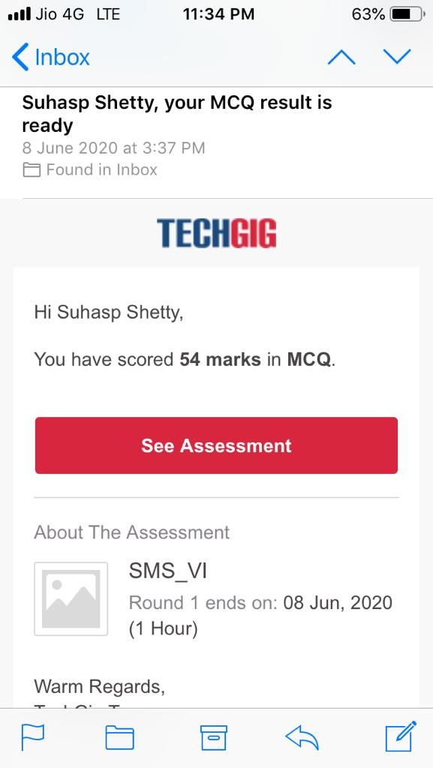

**Certification Course Details:**

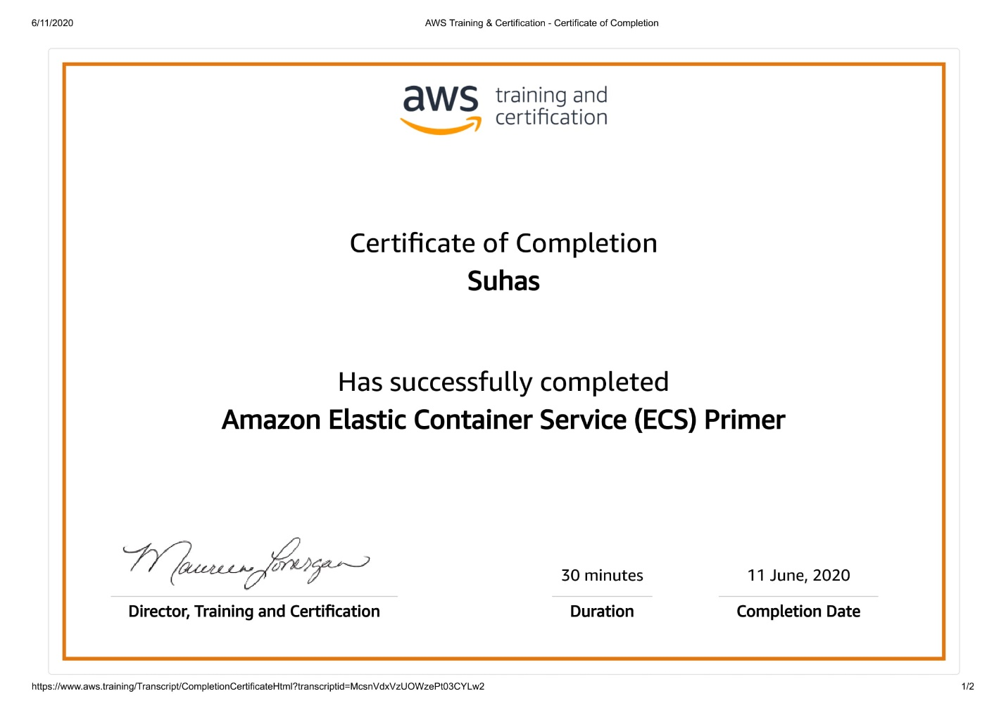

**Coding Challenges Details**

**def convertToBinary(n):**

**if n > 1:**

**convertToBinary(n//2)**

**print(n % 2,end = '')**

**dec = 34**

**convertToBinary(dec)**

**print()**